# AWS vs GCP Report

*Surabhi Patil, 001251860,* [patil.sur@husky.neu.edu](mailto:patil.sur@husky.neu.edu)

*Amitha\_Murali, 001643826, murali.a@husky.neu.edu   
Jyoti Sharma, 001643410,* [sharma.j@husky.neu.edu](mailto:sharma.j@husky.neu.edu)

It’s no surprise that cloud computing has literally taken the world by storm. For most businesses and enterprises, gone are the days of struggling with complicated on-premise server rooms and complicated networking. Over the past decade, cloud computing has become more cost-efficient, secure, and reliable.

Today we’re going to compare just two of major cloud computing providers, **Google Cloud vs AWS**.

**Cloud Computing Trends**

Before we dive into the comparison of Google Cloud vs AWS, let’s take a look at some of the latest cloud computing trends. It’s an exciting industry to be a part of. In January 2017, RightScale conducted its sixth annual [State of the Cloud Survey](https://www.rightscale.com/blog/cloud-industry-insights/cloud-computing-trends-2017-state-cloud-survey) in which they interviewed over 1,000 IT professionals to analyze current cloud computing trends. We can definitely see some interesting things happening.

* In 2016, 32% of participants responded saying that the number one cloud challenge was **due to the lack of resources or expertise**. In 2017, this number has dropped down to 25%.
* In 2016, 29% of participants responded saying that they were **concerned with security** as it pertains to cloud computing. In 2017, this number has dropped down to 25%.
* In 2016, 15% of participants responded said that **performance was a challenge** when it comes to cloud computing. In 2017, this number has dropped down to 11%.

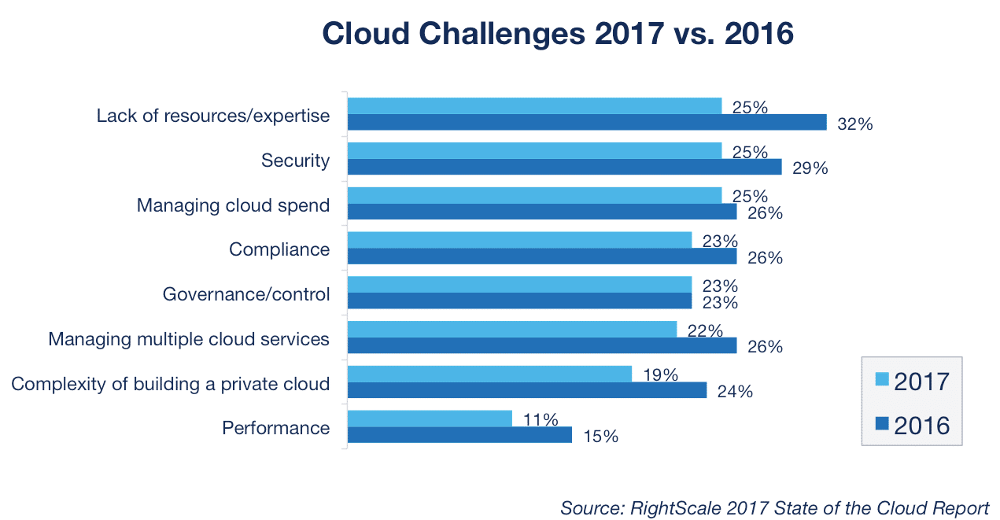

Another interesting aspect of their survey was to see the public cloud adoption statistics of 2017 vs 2016. AWS has stayed right around the same, while Azure and Google Cloud have both seen a fairly significant amount of growth. AWS definitely still is the leader, but this is mainly due to them being the first ones to really invest and shape the cloud computing industry. Google Cloud and Azure definitely have some catching up to do.

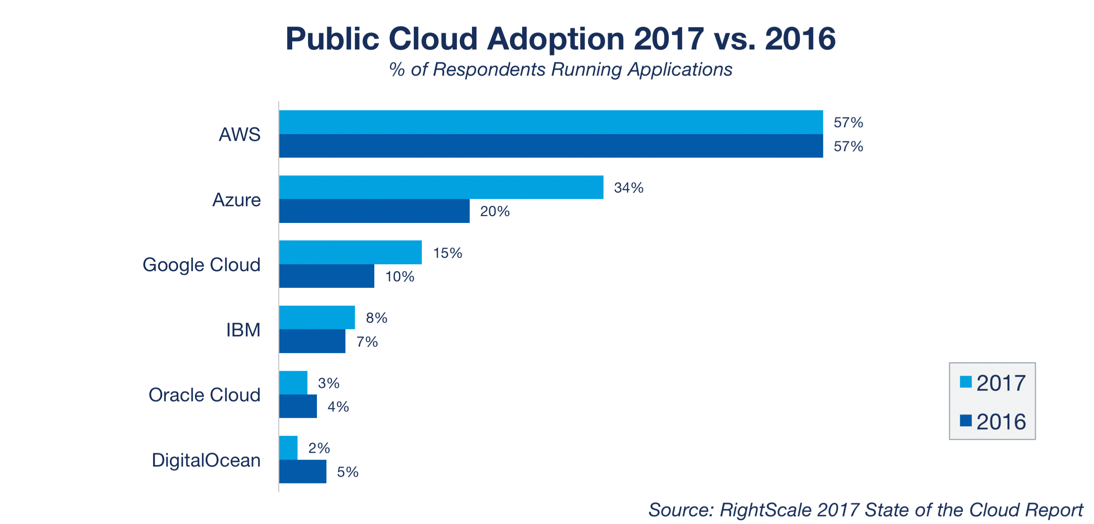

## **Google Cloud Platform**

[Google Cloud Platform](https://cloud.google.com/) is essentially made up of a lot of different services and solutions which allow you to utilize the same software and hardware infrastructure that Google uses for their own products, such as YouTube and Gmail. They launched their first service, Google App Engine in a [public preview](http://googleappengine.blogspot.nl/2008/04/introducing-google-app-engine-our-new.html) in 2008.

Big brands now utilizing Google Compute Engine include HTC, Best Buy, Ubisoft, Philips, Domino’s Pizza, Leadpages, Heathrow, PayPal Coca-Cola, Evernote, Sony Music, and many more. Google Chief Executive Officer Sundar Pichai said Google Cloud Platform is a top-three priority for the company.

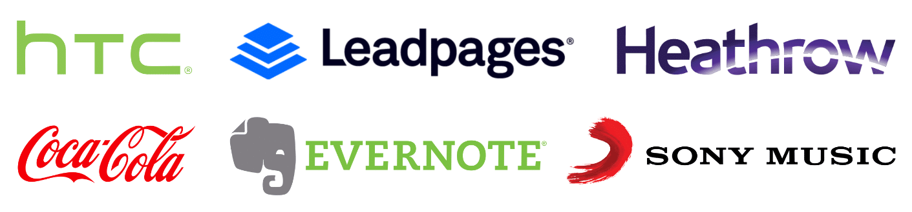

## **Amazon Web Services (AWS)**

[Amazon Web Services](https://aws.amazon.com/) (AWS) is a subsidiary of Amazon.com which launched to provide cloud computing services to businesses and individuals back in 2006. Just like Google Cloud Platform, they have a multitude of different services and solutions. Amazon has definitely paved the way for cloud computing!

Amazon EC2 was launched in a [public beta](https://aws.amazon.com/blogs/aws/amazon_ec2_beta/) back in August 2006. If you compare this against GCE, they have a six-year head start on Google. Big brands utilizing Amazon EC2 include Netflix, Time Inc., Nasa, Expedia, Airbnb, Lamborghini, and many more.



## **Google Cloud vs AWS**

Because Google Cloud and AWS are very similar, it’s easier to break down our comparison into different categories. We can’t cover everything in this post as each provider has well over 50 different products (AWS has over 200)! So we’ll cover products such as compute instances, billing, networking, storage

* [Compute](https://kinsta.com/blog/google-cloud-vs-aws/#compute)
* [Storage/Disk](https://kinsta.com/blog/google-cloud-vs-aws/#storage)
* [Network](https://kinsta.com/blog/google-cloud-vs-aws/#network)
* [Billing and Pricing](https://kinsta.com/blog/google-cloud-vs-aws/#billing-pricing)
* [Support and Uptime](https://kinsta.com/blog/google-cloud-vs-aws/#support-uptime)
* [Security](https://kinsta.com/blog/google-cloud-vs-aws/#security)

## **Compute**

The first category is how Google Compute Engine and AWS EC2 handle their virtual machines (instances). The technology behind Google Cloud’s VMs is [KVM](https://www.linux-kvm.org/), whereas the technology behind AWS EC2 VMs is [Xen](https://www.xenproject.org/). Both offer a variety of predefined instance configurations with specific amounts of virtual CPU, RAM, and network. However, they have a different naming convention, which can at first be confusing. Google Compute Engine refers to them as **machine types**, whereas Amazon EC2 refers to them as **instance types**.

* You can equip Google Compute Engine instances with up to 96 vCPUs and 624 GB of RAM ([New machine types](https://cloudplatform.googleblog.com/2017/10/new-compute-engine-machine-types.html) released October 5th, 2017).
* You can equip AWS EC2 instances with up to 128 vCPUs and 3,904 GB of RAM.

Below is a comparison of VMs that fall into similar categories across providers, such as high memory, high CPU, SSD storage, etc.

| **Machine/Instance Type** | **Google Compute Engine** | **AWS EC2** |
| --- | --- | --- |
| Shared | f1-micro g1-small | t2.nano – t2.2xlarge |
| Standard | n1-standard-1 – n1-standard-96 (beta) | m3.medium – m3.2xlarge m4.large – m4.16xlarge |
| High Memory | n1-highmem-2 – n1-highmem-96 (beta) | r3.large – r3.8xlarge r4.large – r4.16xlarge x1.16xlarge – x1e.32xlarge |
| High CPU | n1-highcpu-2 – n1-highcpu-96 (beta) | c3.large – c3.8xlarge c4.large – c4.8xlarge |
| GPU | You can add GPUs to machine types | g2.2xlarge g2.8xlarge |
| SSD Storage | n1-standard-1 – n1-standard-32 n1-highmem-2 – n1-highmem-32 n1-highcpu-2 – n1-highcpu-32 | i2.xlarge – i2.8xlarge |
| Dense Storage | N/A | d2.xlarge – d2.8xlarge |

It should also be noted that Google Cloud allows you to depart from the predefined configurations as seen above and customize your instance’s CPU and RAM resources to fit your workload. These are known as **custom machines**. Other types include [Google Cloud Preemptible VMs](https://cloud.google.com/preemptible-vms/) and [AWS EC2 Spot Instances](https://aws.amazon.com/ec2/spot/).

## **Storage/Disk**

The type of storage and disks used by a cloud provider play a very important part, as they have a direct impact on performance, such as expected throughput (IO), max IOPs per volume/instance, and the ability to burst capacity for short times. There are two primary types of storage options when you compare Google vs AWS: **block storage** and **object storage**.

### **Block Storage**

Block storage is essentially virtual disk volume used in conjunction with cloud-based virtual machines. Google Compute Engine offers [persistent disks](https://cloud.google.com/persistent-disk/), whereas AWS EC2 offers this via their [Elastic Block Store](https://aws.amazon.com/ebs/) (EBS).

| **Block Storage** | **Google Cloud Platform** | **AWS** |
| --- | --- | --- |
| Service | SSD | General and Provisioned IOPS SSD |
| Volume Sizes | 1 GB to 64 TB | 1 GB to 16 TB 4GB to 16 TB Provisioned IOPS |
| Max IOPs per volume | 40,000 read, 30,000 write | 10,000 (20,000 for Provisioned IOPS) Max IOPS of 75,000/instance |
| Max Throughput per volume (MB/s) | 800 read, 400 write | 160 (320 for Provisioned IOPS) |
| Replication | Built-in redundancy | RAID-1 |
| Snapshot Redundancy | Multiple locations | Multiple locations |
| Encryption | SSE 256-bit AES | SSE 256-bit AES |
| Encryption | SSE 256-bit AES | SSE 256-bit AES |
| Magnetic Pricing (per GB/month) | $0.040 (standard disk) | $0.045 |
| SSD Pricing (per GB/month) | $0.170 | $0.10 |
| PIOPS SSD Pricing (per GB/month) | N/A | $0.125 |

### **Object Storage**

Object storage, also sometimes referred to as distributed object storage, are essentially hosted services for storing and accessing large numbers of binary objects, or blobs. Google Compute Engine offers this via their [Google Cloud Storage](https://cloud.google.com/storage/) service, whereas AWS offers this via their [Amazon S3](https://aws.amazon.com/s3/) service.

| **Object Storage** | **Google Cloud Platform** | **AWS** |
| --- | --- | --- |
| Service | Google Cloud Storage | Amazon S3 |
| Hot | GCS | S3 Standard |
| Cool | GCS Nearline | S3 Standard (Infrequent access) |
| Cold (Archival) | GCS Coldline | Glacier |
| Size Limit | 5 TB/object | 5 TB/object |
| Object Limit | Unlimited | Unlimited |
| Hot Multi-Region Pricing (per GB/month) | $0.0260 Includes transfer | S3 Standard(x2) $0.0460 Transfer $0.0100 |
| Hot Single Region Pricing (per GB/month) | $0.0200 | $0.0230 |
| Cool Single Region Pricing (per GB/month) | $0.0100 (Nearline) | $0.0125 (Infrequent access) |
| Cold Single Region Pricing (per GB/month) | $0.0070 (Coldline) | $0.0040 (Glacier) |

In addition to standard networked block and object storage, Compute Engine and Amazon EC2 both allow users to use disks that are locally attached to the physical machine running the instance. Local storage offers superior performance, very high input/output operations per second (IOPS), and very low latency compared to persistent disks. This type of storage is even capable of achieving several GBs read/write speeds, which is huge!

Google Cloud calls these local SSDs, whereas AWS EC2 refers to them as instance store volumes. Google allows you to attach local SSDs to any instance type whereas AWS only supports the following instance types: C3, F1, G2, HI1, I2, I3, M3, R3, and X1. In August 2017, Google Cloud also announced a [price cut on their local SSDs](https://cloudplatform.googleblog.com/2017/08/announcing-price-cuts-on-Local-SSDs-for-on-demand-and-preemptible-instances.html) for both on-demand and preemptable instances.

## **Network**

Google Cloud and AWS both utilize different networks and partners to interconnect their data centers across the globe and deliver content via ISPs to end users. They offer a variety of different products to accomplish this.

| **Product** | **Google Cloud Platform** | **AWS** |
| --- | --- | --- |
| VPC | Virtual Private Cloud | Amazon VPC |
| Load Balancing | Cloud Load Balancing | Elastic Load Balancing |
| CDN | Cloud CDN | Amazon CloudFront |
| Interconnect | Cloud Interconnect | AWS Direct Connect |
| DNS | Cloud DNS | Amazon Route 53 |
| Tiers | Network Service Tiers | N/A |

* The achievable network capacity on Google Compute Engine instances works slightly differently as it is [based on the quantity of CPUs](https://cloud.google.com/compute/docs/networks-and-firewalls#egress_throughput_caps) your VMs have. Each core is subject to a 2 Gbits/second (Gbps) cap for peak performance. Each additional core increases the network cap, up to a theoretical maximum of 16 Gbps for each virtual machine.
* Amazon EC2 instances have a [maximum bandwidth of 25 Gbps](https://aws.amazon.com/about-aws/whats-new/2017/09/announcing-improved-networking-performance-for-amazon-ec2-instances/), however, this is only on the largest instance sizes. Standard instances max out at 10 Gbps/second.

A big factor when it comes to comparing the two providers is network latency. Latency is important when it comes to businesses that serve visitors in a specific geographical location. For example, let’s say you have an e-commerce shop in Frankfurt, and 90% of your customers are from Germany. Your business is going to greatly benefit from placing your site on a server in Germany, vs hosting it in the United States or Asia.

There are few different tools out there which you can utilize to compare latency between providers. [CloudHarmony](https://cloudharmony.com/speedtest" \t "_blank) is one of which provides objective, impartial and reliable performance analysis to compare cloud services. They utilize a network of about 50 servers located throughout the world to periodically measure and record latency and throughput measurements to other clouds. We ran a test of both Google Compute Engine and AWS EC2 from our current location in the US.

As you can see above, Google Cloud latency was definitely the winner here. But remember, the test is running from our current location, so results will always vary. One of the best ways to measure latency and ping times is to spin up small instances on each provider and run your own tests. But here are a few other nifty little test tools you might want to check out:

* [GCP Ping](http://www.gcping.com/) (measure latency to Google Cloud)
* [CloudPing.info](http://www.cloudping.info/) (measure latency to AWS)

### **Google Cloud Platform Network**

Let’s first take a look at the network behind Google Cloud Platform. Google has been heavily investing in their global infrastructure, which includes new data centers. In fact, over half of their current locations where opened in 2017.

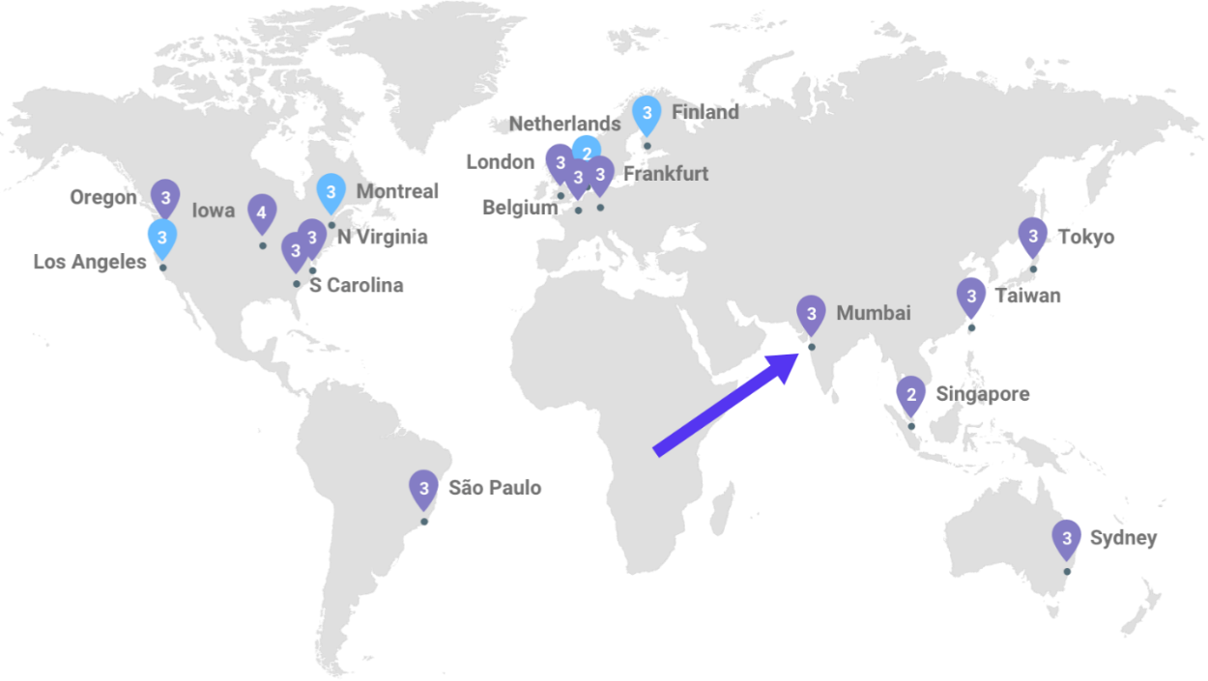

As of November 2017, Google Cloud currently has [13 locations](https://kinsta.com/knowledgebase/google-cloud-data-center-locations/) to choose from to spin up new Compute Engine instances:

* Council Bluffs, Iowa, USA  (us-central1)
* St. Ghislain, Belgium (europe-west1)
* Changhua County, Taiwan (asia-east1)
* Sydney, Australia (australia-southeast1)
* The Dalles, Oregon, USA (us-west1)
* Ashburn, Virginia, USA (us-east4)
* Moncks Corner, South Carolina, USA (us-east1)
* São Paulo, Brazil (southamerica-east1)
* London, UK (europe-west2)
* Frankfurt, Germany (europe-west3)
* Jurong West, Singapore (asia-southeast1)
* Tokyo, Japan (asia-northeast1)  
  Mumbai, India (asia-south1)

For those needing even faster-networking options, Google announced their [Dedicated Interconnect](https://cloudplatform.googleblog.com/2017/09/announcing-dedicated-interconnect-your-fast-private-on-ramp-to-Google-Cloud.html) options in September 2017. Dedicated Interconnect offers several different enterprise-grade network options that you can now utilize to connect to Google Cloud Platform:

#### Interconnect

* Direct access to RFC1918 IPs in your VPC – with SLA
* Dedicated Interconnect
* IPsec VPN

#### Peering

* Access to Google public IPs only – without SLA
* Direct Peering
* Carrier Peering

### **AWS Network**

Now let’s take a look at the [global AWS network](https://aws.amazon.com/about-aws/global-infrastructure/). The AWS Cloud operates 44 availability zones within 16 geographical regions around the world. Unlike Google Cloud, each AWS Region has multiple availability zones and data centers. This is great for redundancy, fault tolerance, and low latency.

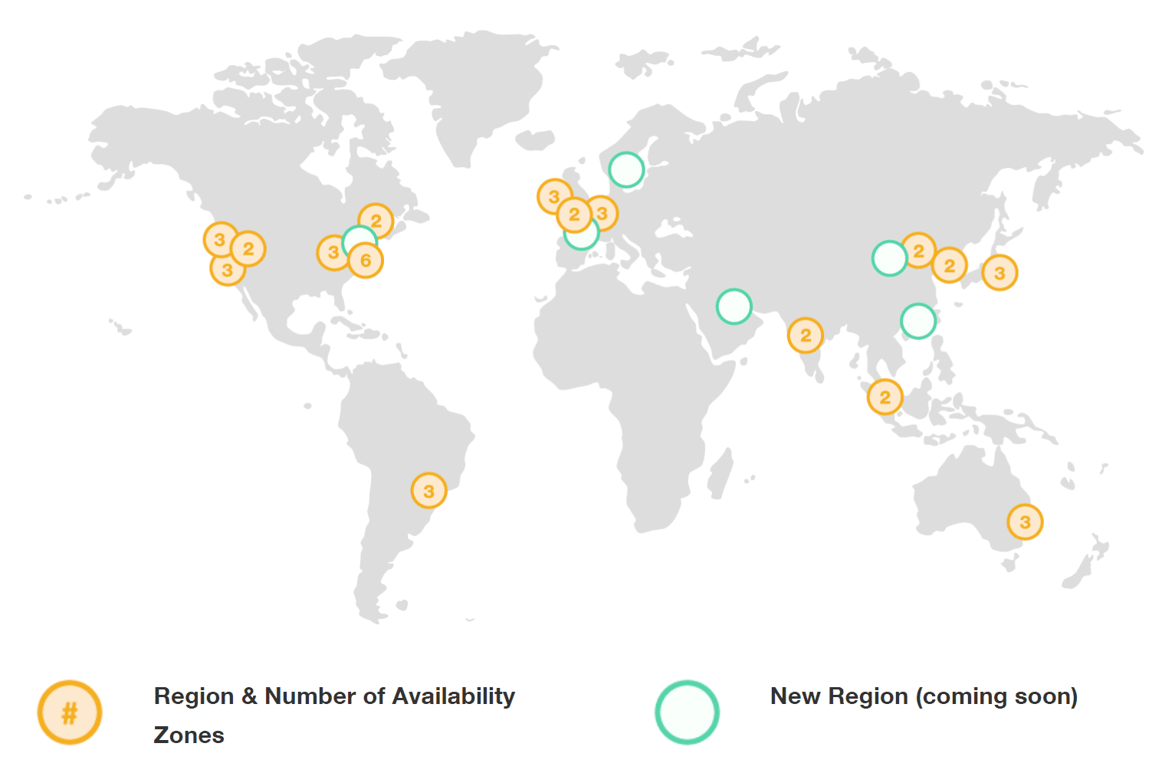

* N. Virginia (6), Ohio (3), USA
* N. California (3), Oregon (3), USA
* Mumbai (2), Seoul (2), Singapore (2), Sydney (3), Tokyo (3), Asia Pacific
* Central (2), Canada
* Beijing (2), China
* Frankfurt (3), Ireland (3), London (2), Europe
* São Paulo (3), South America
* AWS GovCloud (US-West), USA

Just like with Google Cloud’s Dedicated Interconnect, Amazon also offers what they call [AWS Direct Connect](https://aws.amazon.com/directconnect/). AWS Direct Connect lets you establish a dedicated network connection between your network and one of the AWS Direct Connect locations. AWS offers carrier peering, but doesn’t offer direct peering or CDN peering.

They also offer their [Amazon Virtual Private Cloud](https://aws.amazon.com/vpc/) (VPC) and additional ways to accelerate content delivery via [Amazon CloudFront](https://aws.amazon.com/cloudfront/).

## **Billing and Pricing**

When comparing Google Cloud vs AWS, billing is handled quite differently. And to be honest, neither of them provide a very straightforward way of easily calculating this unless you are very familiar with the platforms. Here are their monthly calculators if you’re just getting started:

* [AWS simple monthly calculator](https://calculator.s3.amazonaws.com/index.html)
* [Google Cloud Platform pricing calculator](https://cloud.google.com/products/calculator/)

 Essentially AWS offers you a dashboard which provides insights into your bill. Google Cloud Platform provides estimated exports via their BigQuery tool. However, both providers are doing things to decrease costs and make billing easier.

### **Per Second Billing**

AWS announced their [per second billing](https://aws.amazon.com/blogs/aws/new-per-second-billing-for-ec2-instances-and-ebs-volumes/) in September 2017 (one-minute minimum on EC2 instances). This allows for greater flexibility for clients who need to spin up new instances and do a lot of work in a short amount of time. Not to our surprise, Google Cloud Platform also launched their [per second billing](https://cloudplatform.googleblog.com/2017/09/extending-per-second-billing-in-google.html) (one-minute minimum on Google Compute Engine instances). This goes to show you how competitive this market really is. AWS and GCP are almost launching new features simultaneously now. We even have a hard time keeping up!

### **Committed Use Discounts vs Reserved Instances**

Both Google Cloud and AWS provide different ways to save for those seriously invested in their platforms. AWS EC2 offers what they call [Reserved Instances](https://aws.amazon.com/ec2/pricing/reserved-instances/), which provide a significant discount (up to 75%) compared to on-demand pricing and provide a capacity reservation when used in a specific availability zone. They have different types of reserved instances:

* Standard Reserved Instances
* Convertible Reserved Instances
* Scheduled Reserved Instances

Google Cloud has what they all [Committed Use Discounts](https://cloudplatform.googleblog.com/2017/09/committed-use-discounts-for-Google-Compute-Engine-now-generally-available.html), which is now available to all Compute Engine customers as of September 2017. This is basically the ability to purchase committed use contracts in return for deeply discounted prices for VM usage.

[comparison of Google Cloud Committed Use Discounts vs AWS Reserved Instances](https://www.rightscale.com/blog/cloud-cost-analysis/aws-reserved-instances-vs-google-committed-use-discounts)

* When comparing Google’s 1–year Committed Use Discount to the AWS 1-year Standard RI, the total cost of the Google environment was **28 percent less than AWS**.
* When comparing Google’s 3-year Committed Use Discount to the AWS 3-year Convertible RI, the total cost of the Google environment was **35 percent less than AWS**.

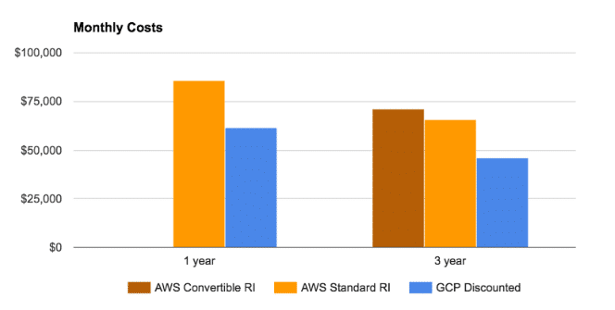

### **Sustained Discounts**

Another really huge cost-saving discount that Google Cloud offers is what they call [Sustained Use Discounts](https://cloud.google.com/compute/docs/sustained-use-discounts). These are automatic discounts that Google Cloud Platform provide the longer you use the instance, unlike with AWS where you have to reserve the instance for a long period of time.

### **Free Trials**

Just starting out, or perhaps you ware wanting to compare the cloud providers for yourself? Not to worry as **both of them have great free trials**.

Google Cloud offers a $300 credit which lasts for 12 months. And as of March 2017, they also have a [free tier](https://cloud.google.com/free/) with **no time limits attached**. Here is an example of an instance you could run forever for free with GCP:

* f1-micro instance with 0.2 virtual CPU, 0.60 GB of memory, backed by a shared physical core. (US regions only)
* 30 GB disk with 5 GB cloud storage

AWS also offers a [12-month free trial](https://aws.amazon.com/s/dm/optimization/server-side-test/free-tier/free_nc/#details). Here is an example of an instance you can run:

* t2.micro instance with 750 hours/month
* 30 GB disk (including 750 hours/month of a managed MySQL database) with 5GB cloud storage

### **Uptime**

Both [Google Compute Engine](https://cloud.google.com/compute/sla) and [AWS EC2](https://aws.amazon.com/ec2/sla/) both have SLAs which provide a monthly uptime percentage of at least 99.95%. No provider is perfect.

One advantage to AWS when it comes to [uptime](https://kinsta.com/blog/website-downtime/) is that you have the ability to get different machines within their multiple availability zones per region. With Google Cloud, it could very well be that your instances might be on the same machine per region. However, Google Cloud also has a unique feature with their ability to live migrate virtual machines. Benefits of live migrations allow for the engineers at Google to better address issues such as patching, repairing, and updating the software and hardware, without the need for you to worry about machine reboots.

## **Security**

In their [Second Annual Cloud Computing Survey](https://clutch.co/cloud/resources/cloud-computing-security-survey-2017) (2017), Clutch surveyed 283 IT professionals at businesses across the United States that currently use a cloud computing service. In regards to security, they found that almost 70% of professionals were more comfortable storing data in the cloud than their previous legacy systems.

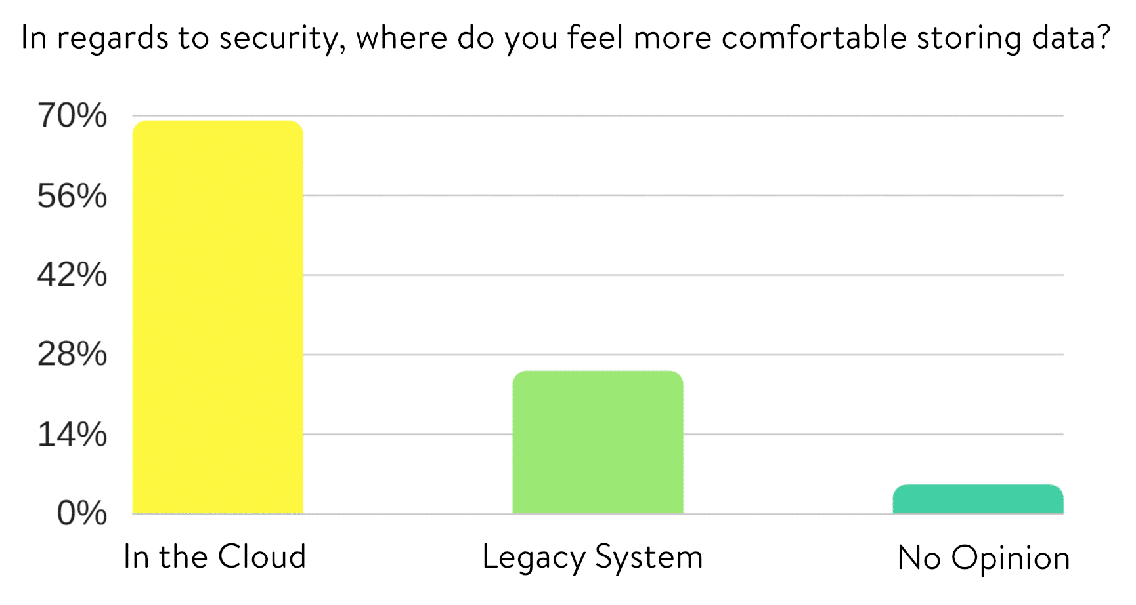

They also asked the respondents to list the [top benefits of using the cloud](https://clutch.co/cloud/resources/annual-cloud-computing-survey-2017) and the largest percentage (45%) responded with security as being the top benefit.

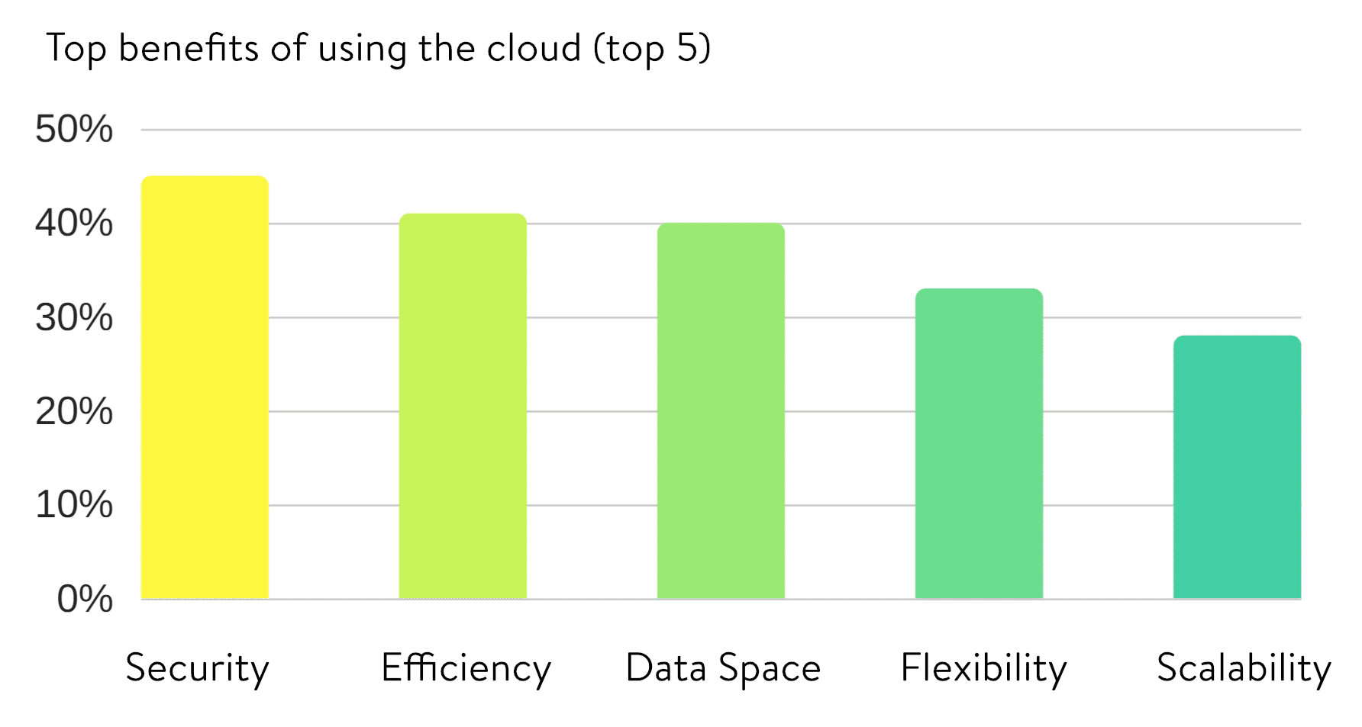

### **Google Cloud Security**

When looking at Google Cloud Platform’s security, it’s important to remember that this is one area where they have been improving long before GCP even launched. You get the benefit of a [security model](https://cloud.google.com/security/) that has been built upon over the course of 15 years, and currently secures products and services like Gmail, Search, etc. Google currently employs more than 500 full-time security professionals.

Some of Google Cloud Platform security features include:

* All data is encrypted in transit between Google, the customers, and data centers **by default**; as well as the data in all of the Cloud Platform services. The data stored on persistent disks is encrypted under 256-bit AES and each encryption key is also encrypted with a set of regularly changed master keys.
* Commitment to enterprise security certifications with regular audits for SSAE16, ISO 27017, ISO 27018, PCI, and HIPAA compliance Eran Feigenbaum, Director of Security at Google stated “Certifications such as these provide independent third-party validations of our [ongoing commitment to world-class security and privacy](http://googleforwork.blogspot.com/2016/04/new-security-and-privacy-certifications-give-more-transparency-on-how-Google-handles-your-data-in-the-cloud.html), while also helping our customers with their own compliance efforts.”
* Because Google has relationships with some of the biggest ISPs in the world, this helps improve the security of your data in transit as it means less hops across the public internet.
* The layers of the Google application and storage stack require that requests coming from other components are authenticated and authorized.
* [Google Cloud Identity and Access Management](https://cloud.google.com/iam/docs/understanding-custom-roles) (Cloud IAM ) was launched in September 2017 to provide predefined roles that give granular access to specific Google Cloud Platform resources and prevent unwanted access to other resources. This is similiar to AWS IAM.

You can see more in-depth behind the scenes in Google’s [security whitepaper](https://cloud.google.com/security/whitepaper).

### **AWS Security**

Just like Google Cloud Platform, the AWS platform has a [security model](https://aws.amazon.com/security/) that has been improved upon for over a decade. Some of their security features include:

* All data is encrypted in transit between AWS, the customers, and data centers; as well as the data in all of the AWS cloud. The data stored on EC2 instances is encrypted under 256-bit AES and each encryption key is also encrypted with a set of regularly changed master keys.
* Network firewalls built into Amazon VPC, and web application firewall capabilities in AWS WAF let you create private networks, and control access to your instances and applications.
* Flexible key management options, including AWS Key Management Service, allowing you to choose whether to have AWS manage the encryption keys or enable you to keep complete control over your keys.
* Dedicated, hardware-based cryptographic key storage using AWS CloudHSM, allowing you to satisfy compliance requirements.
* AWS Identity and Access Management (IAM), AWS Multi-Factor Authentication, and AWS Directory Services allow for defining, enforcing, and managing user access policies.
* AWS has audit-friendly service features for PCI, ISO, HIPAA, SOC and other compliance standards.

## **Summary**

So who is the winner when it comes to comparing Google Cloud vs AWS? Well, we would say that both providers have their pros and cons. We are excited to see the **rapid rate of global expansion** over the past year. When it comes to **pricing and speed**, Google Cloud Platform is definitely one you want to check out!

AWS of course also has a long-standing history of providing cloud computing services for business and enterprises over the past decade. They really were the first ones to push the cloud industry forward, and are still the one that providers like Google and Azure are copying. Their **support, redundancy, and availability** per region is superb.

# Top 7 Advantages of Choosing Google Cloud Hosting

### **1. Better Pricing Than Competitors**

Google bills in minute-level increments (with a 10-minute minimum charge), so you only pay for the compute time you use. And a big bonus is that they give you discounted prices for long-running workloads with no up-front commitment required. Use the VMs for a month and you get a discount, as simple as that. This makes it perfect for startups and for enterprise IT to cut costs. AWS for example requires prepays in the form of “[reserved instances](https://aws.amazon.com/ec2/purchasing-options/)” to be eligible for the discounts.

# instances are simply lower in cost on Google Cloud Platform, Compute Engine alone is typically between 40% – 50% cheaper than AWS and Azure

**AWS vs Google Cloud**

When it comes to Google Cloud Platform you basically get more IOPS for less than 1/3 of the cost. As you can see with this configuration below with AWS you are looking at $1,102.50/month with 3 year contract as opposed to Google Cloud’s $470.64/month. IOPS is a measurement for input/output operations per second and how often a device can perform IO tasks. In most cases, the great number of IOPS, the better the performance.

# aws vs google cloud

# aws vs google cloud

### **2. Private Global Fiber + Tiered Network**

Alex said it best in an article about [Google Cloud Platform on Techcrunch](https://techcrunch.com/2013/05/19/what-sets-the-google-cloud-platform-apart-from-the-rest/), “The Power is in the Network.” One thing that sets Google Cloud Hosting apart from some of the other players is that their network is one of the biggest in the world. Will Shulman, co-founder of [MongoLab](https://mongolab.com/welcome/" \t "_blank), talked about the network in a panel at Google I/O saying: “It is blazing fast. The other thing – it has a private distributed backbone between all the data centers.

# On June 29, 2016, Google announced their investment in the [FASTER Cable System](http://www.nec.com/en/press/201606/global_20160629_02.html) which gives Google access to up to 10Tbps (Terabits per second) of the cable’s total 60Tbps bandwidth between the US and Japan. They are using this for Google Cloud and Google App customers. The 9,000km trans-Pacific cable is the highest-capacity undersea cable ever built and lands in Oregon in the United States and two landing points in Japan. Google is also one of six members which has sole access to a pair of 100Gb/s x 100 wavelengths optical transmission strands between Oregon and Japan.

# And not only that but as of August 2017, Google Cloud Platform launched their separate [premium tier and standard tier networks](https://cloudplatform.googleblog.com/2017/08/introducing-Network-Service-Tiers-your-cloud-network-your-way.html). This makes them the first major public cloud to offer a **tiered cloud network**. The premium tier delivers traffic over Google’s well-provisioned, low latency, highly reliable global network. Redundancy is key, and that’s why there are at least three independent paths (N+2 redundancy) between any two locations on the Google network, helping ensure that traffic continues to flow between the locations even in the event of a disruption.

# Google Cloud Platform Premium Tier

The standard tier delivers network quality comparable to that of other major public clouds. It delivers outbound traffic from GCP to the internet over transit (ISP) networks instead of Google’s network.

# Google Cloud Platform Standard Tier

### **3. Live Migration of Virtual Machines**

Another huge advantage for Google Cloud Hosting, is **live migrations of Virtual Machines**. Neither AWS, [Azure](https://feedback.azure.com/forums/216843-virtual-machines/suggestions/5763409-live-migrate-the-vms-during-maintenance-hardware-f), or smaller providers like Digital Ocean offer this functionality. So this is a very important differentiator for Google Cloud compared to other cloud providers. As a WordPress hosting provider, this means we are basically always up with our VMs, with no noticeable degradation in performance when they are live migrating VMs between host machines.

# Benefits of live migrations allow for the engineers at Google to better address issues such as patching, repairing, and updating the software and hardware, without the need for you to worry about machine reboots.

# [high-level steps involved in a live VM migration](https://cloud.google.com/compute/docs/instances/live-migration).

# Live VM migration on Google Cloud

And besides live migration of virtual machines, Google also offers [resizing of persistent disks](https://cloudplatform.googleblog.com/2016/03/introducing-Google-Cloud-Persistent-Disks-with-non-disruptive-online-resizing.html)without any downtime. You can use the portal or CLI to actually resize the live disk.

### **4. Improved Performance**

# We have seen the Google Cloud machines easily handle 60k+ concurrent visitors without any hiccups.

# Here is an example below of load times significantly decreasing on a client’s site after we moved them to Google Cloud Platform. Before the move they were getting spikes well over the 1 second range, and after they stayed consistently under 500 ms. So just by migrating them to Google Cloud Platform they saw a **50% decrease in load times!** Their VMs definitely do a good job of handling whatever you throw at them.

# Load time decreasing significantly on a client's site after moving to Google Cloud

### **5. State of the Art Security**

Another big advantage is security. Choosing Google Cloud Platform means you get the benefit of a security model that has been built upon over the course of 15 years, and currently secures products and services like Gmail, Search, etc.

Some of Google Cloud Platform security features include:

* All data is encrypted in transit between Google, the customers, and data centers; as well as the data in all of the Cloud Platform services. The data stored on persistent disks is encrypted under 256-bit AES and each encryption key is also encrypted with a set of regularly changed master keys.
* The layers of the Google application and storage stack require that requests coming from other components are authenticated and authorized.
* Because Google has relationships with some of the biggest ISPs in the world, this helps improve the security of your data in transit as it means less hops across the public internet.
* Commitment to enterprise security certifications with regular audits for regular audits for SSAE16, ISO 27017, ISO 27018, PCI, and HIPAA compliance. Eran Feigenbaum, Director of Security at Google stated “Certifications such as these provide independent third-party validations of our [ongoing commitment to world-class security and privacy](http://googleforwork.blogspot.com/2016/04/new-security-and-privacy-certifications-give-more-transparency-on-how-Google-handles-your-data-in-the-cloud.html), while also helping our customers with their own compliance efforts.”

### **6. Dedication to Continued Expansion**

Google has continued to rapidly build out their infrastructure for Google Cloud Platform. On September 29th, 2016 they announced the locations of [new strategically placed Google Cloud Regions](https://cloudplatform.googleblog.com/2016/09/Google-Cloud-Platform-sets-a-course-for-new-horizons.html). We are very excited to see São Paulo and Sydney included in the list as this will help dramatically decrease latency for Google Cloud Hosting customers across South America and Australia. Here is an updated list of all GCP regions:

#### Coming

* [Hong Kong](https://cloudplatform.googleblog.com/2017/11/coming-in-2018-GCPs-Hong-Kong-region.html) (Coming in 2018)
* Montreal (Canada)
* California (United States)
* Netherlands
* Hamina (Finland)

#### Now Available

* Belgium
* London (UK)
* Council Bluffs, Iowa, USA (current)
* Changhua County (Taiwan)
* [Sydney](https://cloudplatform.googleblog.com/2017/06/Google-Cloud-Region-in-Sydney.html) (Australia) – Available as of June 2017
* Oregon (United States)
* Frankfurt (Germany)
* South Carolina (United States)
* São Paulo (Brazil) – Available as of September 2017
* [Northern Virginia](https://cloudplatform.googleblog.com/2017/05/Google-Cloud-Platform-launches-Northern-Virginia-region.html) (United States) – Available as of May 2017
* Singapore – Available as of May 2017
* [Tokyo (Japan)](https://blog.google/topics/google-cloud/google-cloud-platform-tokyo-region-now-open-for-business/) – Available as of November 2016
* [Mumbai (India)](https://cloudplatform.googleblog.com/2017/10/GCP-arrives-in-India-with-launch-of-Mumbai-region.html) – Available as of October 2017

# Google Cloud data center locations

### **7. Redundant Backups**

Google Cloud Storage is designed for 99.999999999% durability and has 4 different types of storage: Coldline storage, nearline, regional storage, and [multi-regional storage](https://cloud.google.com/storage/docs/storage-classes#multi-regional). It stores data redundantly, with automatic checksums to ensure data integrity. The beauty of multi-regional storage is that it is also geo-redundant, which means cloud storage **stores your data redundantly in at least two regions** within the multi-regional location of the bucket. As it pertains to Google Cloud hosting, this ensures you will never lose your data, even in the case of a disaster.

## **Summary**

As you can see, when it comes to Google Cloud Hosting and utilizing Google Cloud Platform, there are a lot of advantages. Not only is it cheaper, but you also benefit from one of the largest networks in the world! This means less latency and more accurate compute prices as data is able to be processed in less time. Live migration of virtual machines is currently a unique and very important differentiator when it comes to comparing other cloud hosting providers. Top it off with state of the art security and performance that is able to handle hundreds of thousands of concurrent connections and you have a platform that can set your business up for long-term success.

# References:

# <https://kinsta.com/blog/google-cloud-vs-aws/>

# <https://kinsta.com/blog/google-cloud-hosting/>